Oxidation & Reduction

OIL RIG

(Oxidation is Loss & Reduction is Gain)

Oxidation number rules:

|  |  |
| --- | --- |
| Atom: | Oxidation number: |
| Elemental state | Zero |
| Monatamic ion | Equal to charge |
| Hydrogen | +1 (but –1 in metal hydrides) |
| Oxygen | –2 (but –1 in peroxides and +2 in F2O) |
| Group I and II elements | +1 and +2 respectively |

When determinng the species that’s oxidised or reduced, we identify the specific atom.

When determining the species that’s the oxidant/oxidising agent/oxidiser or the reductant/reducing agent/reducer, we identify the entire species.

Increase in oxididation number → loss of electrons → oxidised → reductant.

Decrease in oxidation number → gain of electrons → reduced → oxidant.

Metal-metal ion displacement reactions occur when an electron transfer takes place from a metal element to the metal ion of a less reactive metal.

e.g., Zn (s) + Mg2+(aq) → Zn2+(aq) + Mg (s)

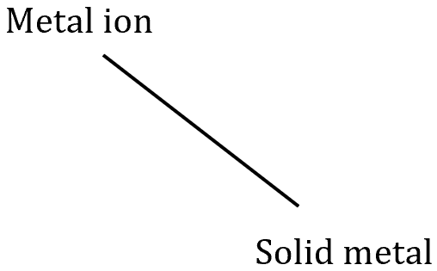

Metal-hydrogen ion displacement reactions occur when an electron transfer takes place from the metal element to the H+ ion.

e.g., Mg (s) + 2H+(aq) → Mg2+(aq) + H2 (g)

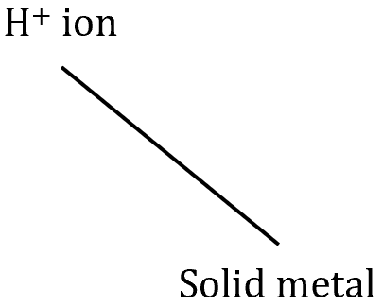

Halogen-halide displacment reactions occur when an electron transfer takes place from a halide ion to a less reactive halogen.

Cl2 (g) + 2Br –(aq) → 2Cl–(aq) + Br2 (aq)

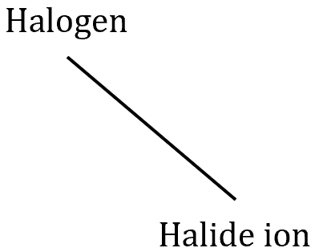

Corrosion is the oxidation of metal in the presence of air. Electrons are transferred from the metal to the oxygen.

e.g., 2Ca (s) + O2 (g) → 2CaO (s)

Rusting is the oxidation of iron in the presence of air. Electrons are transferred from the iron to the oxygen.

2Fe (s) + O2 (g) +2H2O (l) → 2Fe(OH)2 (s)

Half-equations:

1. Balance all atoms.
2. Add XH2O to the side with a deficit of oxygen.
3. Add YH+ to the side with a deficit of hydrogen.
4. Add Ze– to balance charge.
5. Add states.

Balanced, overall redox reactions:

1. Balance the half equation (using the guide outlined above).
2. Multiply the half-equations by A and B so that electron number is balanced.
3. Add the half-equations together, cancelling out any common species.
4. Add states.

Galvanic Cells

| represents phase boundary.

|| represents salt bridge.

Type of electrode for particular half-cells:

* Reactions involving metals and metal ions → electrode = the metal.
* Reactions involving metal ions in different oxidation states → inert electrode (e.g., Cr3+ and Cr6+).
* Reactions involving a dissolved non-metal and its ions → inert electrode (e.g., Br2 and Br –).
* Reactions involving a gaseous non-metal and its ions → inert electrode (e.g., Cl2 and Cl–).

Find the overall reaction and the Eocell.

1. Write the half-cell reduction equations with their Eo values.
2. Determine the reduction half-equation that has the more posive Eo.
3. Calculate Eocell.
4. Reverse the direction of the oxidation half-equation to write the overall redox equation.

Corrosion of Iron

* Corrosion of iron requires both oxygen and water.
* The water acts as an electrolyte and salt bridge.
* Iron oxidation [1] occurs where [O2] is at its lowest.
* Oxygen reduction [2] occurs where [O2] is at its greatest.
* Fe2+ ions then migrate to the cathode to react with OH– ions, forming a precipitate.

**[1] Oxidation (anode)**:

**[2] Reduction (cathode)**:

**[3] Precipitation**:

**[4] Further oxidation of Fe(II) hydroxide**:

**[5] Fe(III) hydroxide may partially dehydrate to form rust,** :

**[6] Overall equation**:

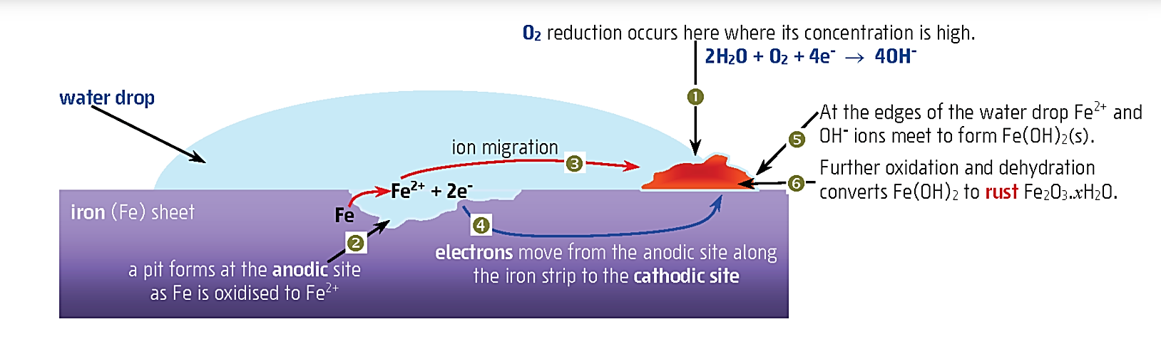

Factors that affect rusting:

1. **Presence of oxygen** – The greater the [O2], the greater the rate of corrosion.
2. **Presence of water** – Increases the flow of ions between the anodic and cathodic sites → increases the rate of corrosion.
3. **pH** – Lower pH makes the reduction of water more favourable → greater rate of corrosion.
4. **Presence of electrolytes** – Improves the efficiency of water as the salt bridge → greater rate of corrosion.
5. **Presence of less or more reactive metals**:

* Iron is in contact with a less reactive metal (more positive Eo) → rate of corrosion increases.
* Iron is in contact with a more reactive metal reactive metal (less positive Eo) → rate of corrosion decreases.

1. **Temperature** – The greater the temperature, the greater the rate of corrosion.

Methods to prevent rusting:

1. **Inert, non-metallic coating** – Prevents contact with oxygen and water (e.g., painting, plastic, oil, etc).
2. **Inert, metallic coating** – Prevents contact with oxygen and water (e.g., Cu, Sn, Pb, etc). This can be problematic if the metal barrier is damaged as it makes the point of contact with iron more anodic → greater rate of corrosion.
3. **Galvanising** – Coating with the more reactive metal, zinc. Zinc oxidises more readily and forms a protective layer over the iron ().
4. **Cathodic protection using a sacrificial anode** – A more reactive metal is placed in contact with the iron. The more reactive metal oxidises and must be replaced periodically. The iron now becomes the site for reduction so O2 is reduced at this site. A very damp or wet environment is needed to act as a salt bridge.

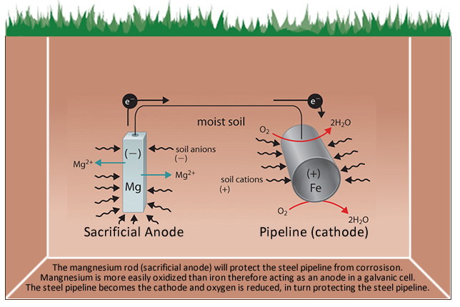

1. **Cathodic protection using a DC** – The iron is connected to the negative terminal of a low voltage DC, causing an excess of electrons which prevents oxidation. The positive terminal of the power supply is attached to a piece of scrap metal or an inert material (e.g., Pt which causes oxidation of H2O) that’s oxidised over time.

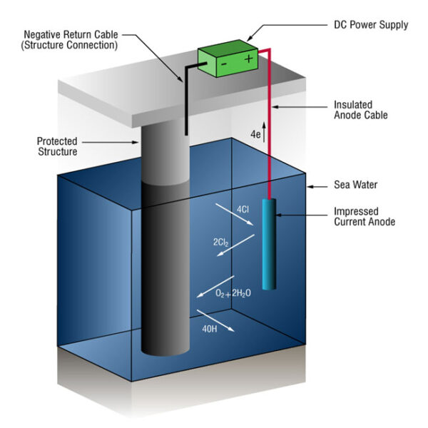

Electrolytic Cells

* Anode is positive.
* Cathode is negative.

Electrolysis of a molten salt:

* Applied voltage causes the cathode to become negatively charged, causing cations to become attracted to it where they’re reduced.
* Applied voltage causes the anode to become positively charged, causing anions to become attracted to it where they’re oxidised.
* In a molten salt, the ions are converted to their elemental forms.

Electrolysis of aqeous solution:

* Applied voltage causes the cathode to become negatively charged, causing cations to become attracted to it where they’re reduced.
* Applied voltage causes the anode to become positively charged, causing anions to become attracted to it where they’re oxidised.
* The aqeous salt, electrode(s) or water may be oxidised or reduced.
* Choose the most positive reduction and oxidation options.

Reduction of water:

Oxidation of water:

Diagram of electrochemical cell:

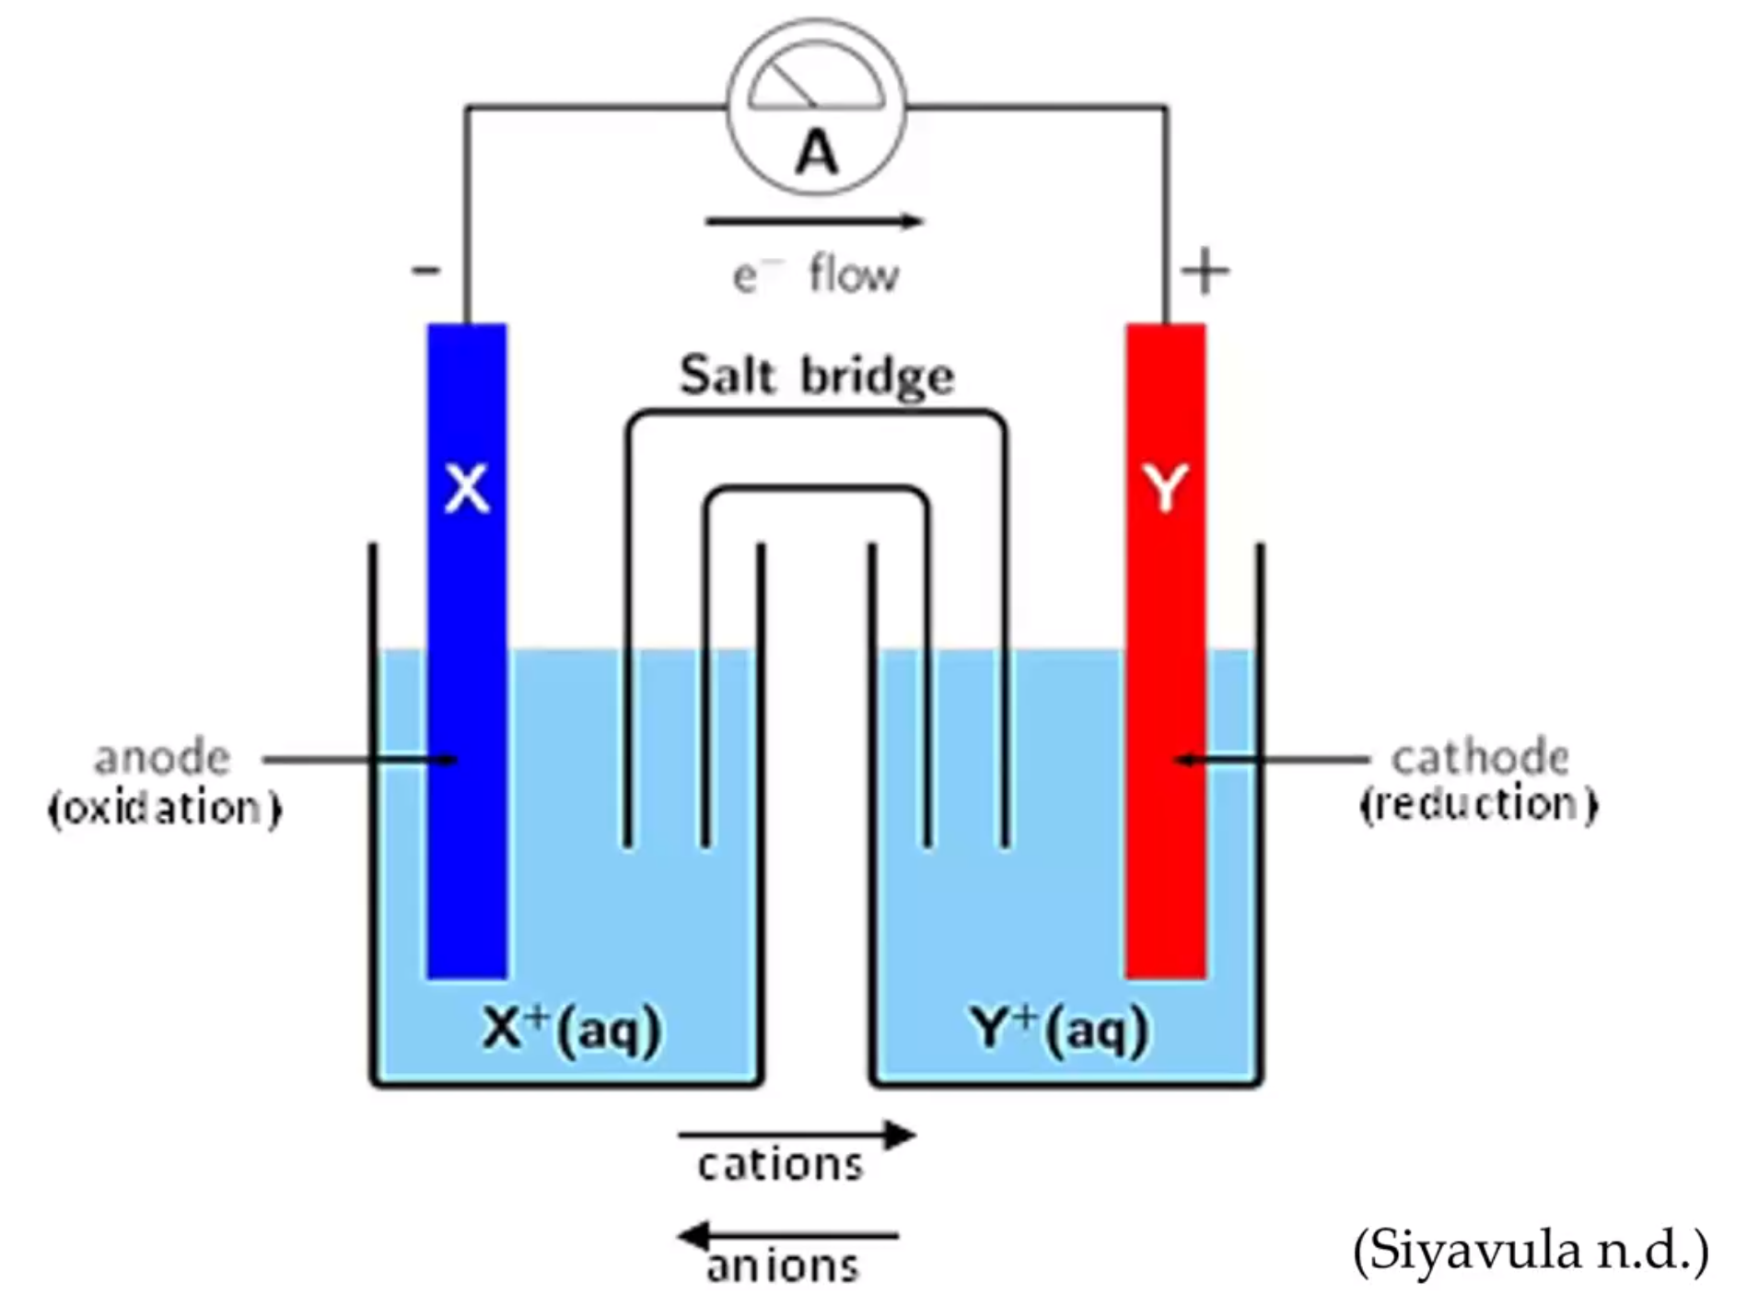

Applications of Electrochemical Cells

Electrolysis of molten NaCl – The Downs Cell:

* NaCl is made commercially available through the electrolysis of molten NaCl.
* The melting point of NaCl is reduced by adding CaCl2 to the mixture.
* Anode is graphite:
* Cathode is iron:
* The chlorine is is piped off as gas and the molten sodium is tapped off in the absence of air.
* The chlorine gas and molten sodium must be kept separate as they’re reactive enough to form molten NaCl.
* Electrowinning: The process of commercially producing metals from their molten salts.

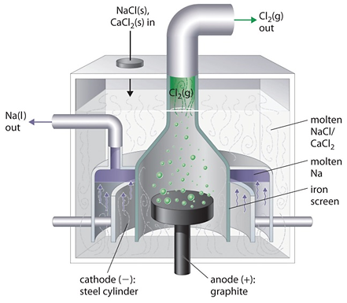

Electroplating:

* The process of electrolysing to place a thin film of metal on an object.
* Anode is the metal to be used as the coating.
* Cathode is the object to be coated.

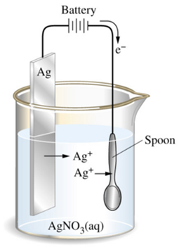

* Anode:
* Cathode:

Electrorefining:

* Purifying a metal where the impure metal anode is itself oxidised.
* The voltage is carefully controlled so as to only oxidise the required metal and not the metals from impurities.

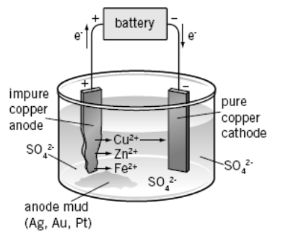

Primary cells:

* Non-rechargeable cells typically used as disposable batteries.
* Leclanché cell:
* Produces a voltage of +1.48V.
* Anode is zinc (the casing):
* Cathode is a graphite rod surrounded by powdered MnO2:
* Overall:
* Electrolyte is a moist paste of NH4Cl and ZnCl2.
* The battery can’t be recharged because the Zn2+ ions are removed from the anode and the NH4+ ions eventually produce an acidic environment which corrodes the zinc casing.

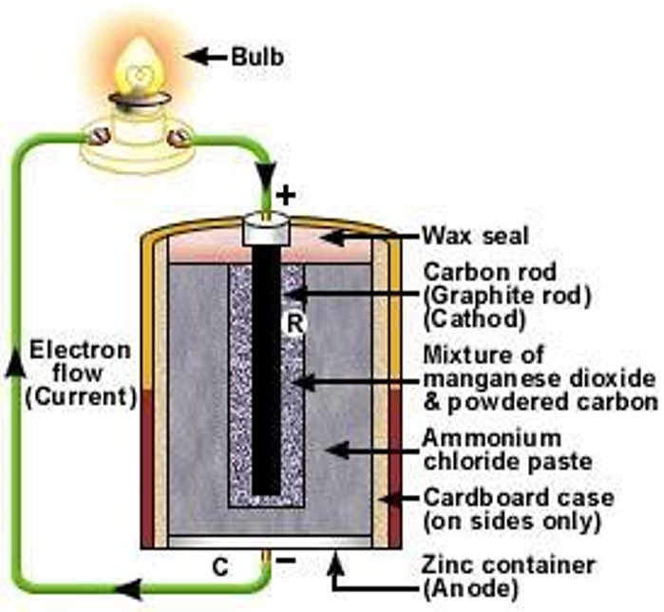

Secondary cells:

* Rechargeable cells typically used as batteries.
* The lead-acid accumulator battery is a secondary cell.
* It’s made up of 6 cells connected in series, producing a voltage of ~12V.
* It produces a much larger current than a dry cell.
* Cathode is a grid of lead alloy packed with PbO2 powder.
* Anode is a grid of lead alloy packed with spongy lead.
* Electrolyte is a solution of 35% v/v H2SO4.

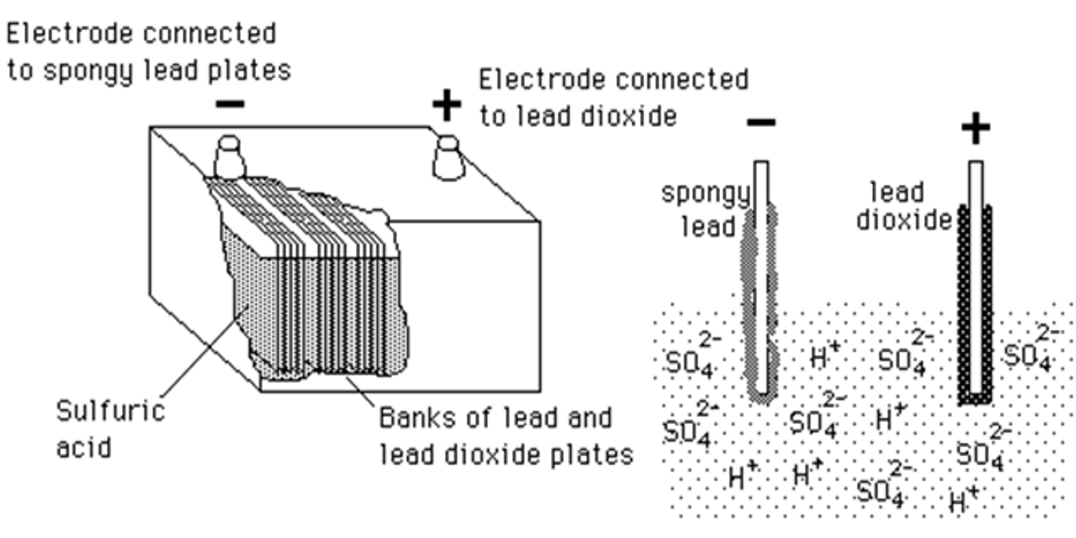

Anode:

Cathode:

Overall:

* The PbSO4 produced coats the electrodes.
* To charge the battery, the car’s alternator provides an electric current which causes the reverse overall reaction to occur.

Fuel cells:

* Don’t store the oxidising or reducing agent.
* Alkaline hydrogen fuel cell:
* Gaseous H2 and O2 are continually fed into the cell, producing water as the only overall waste product.
* Anode:
* Cathode:
* Overall:

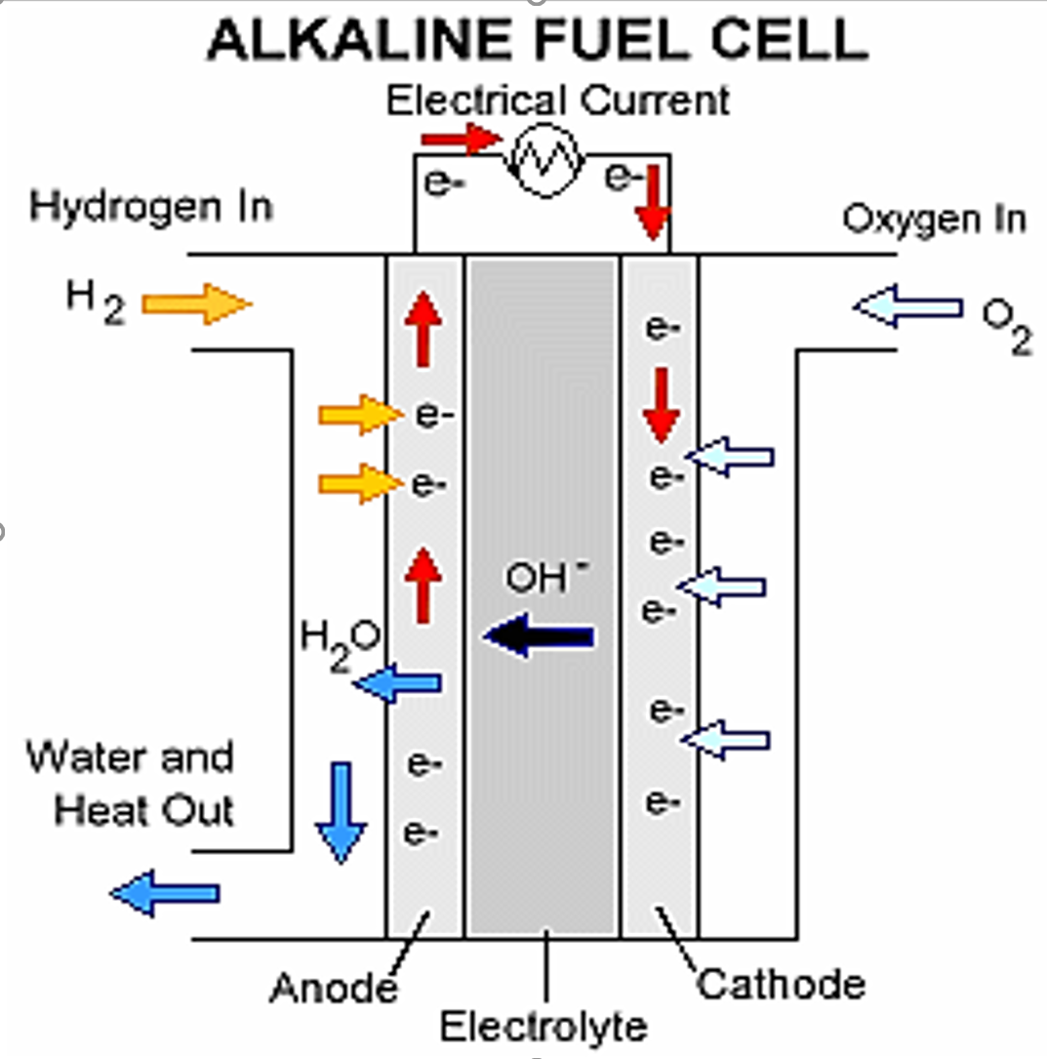

Diagrams

Galvanic cell:

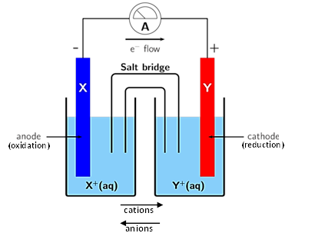

Rusting:



Cathodic protection using a sacrificial anode:



Cathodic protection using a DC current:



Electrolysis of a molten salt:

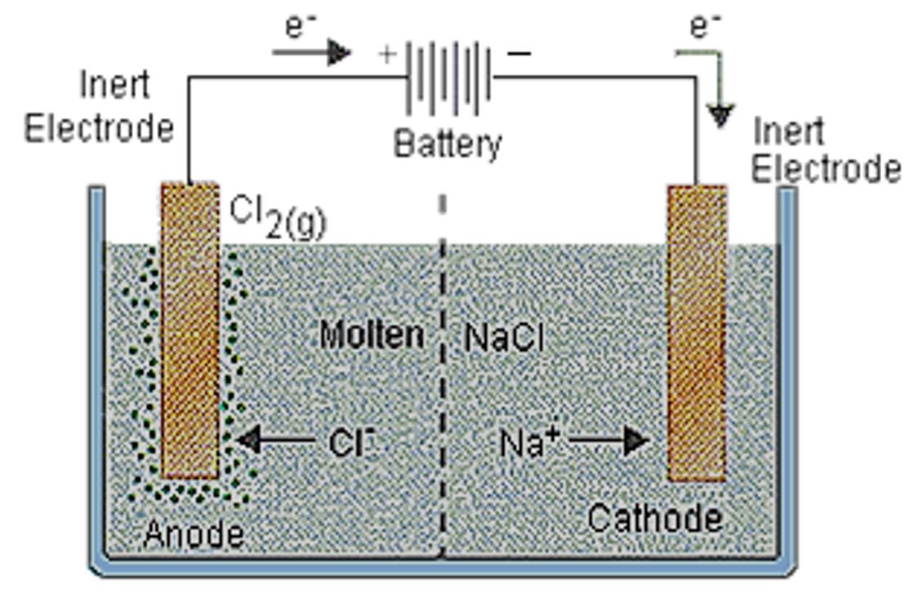

Electrolysis of an aqueous solution:

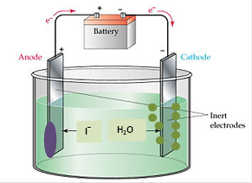

Primary cell:

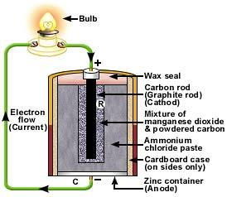

Secondary cell:

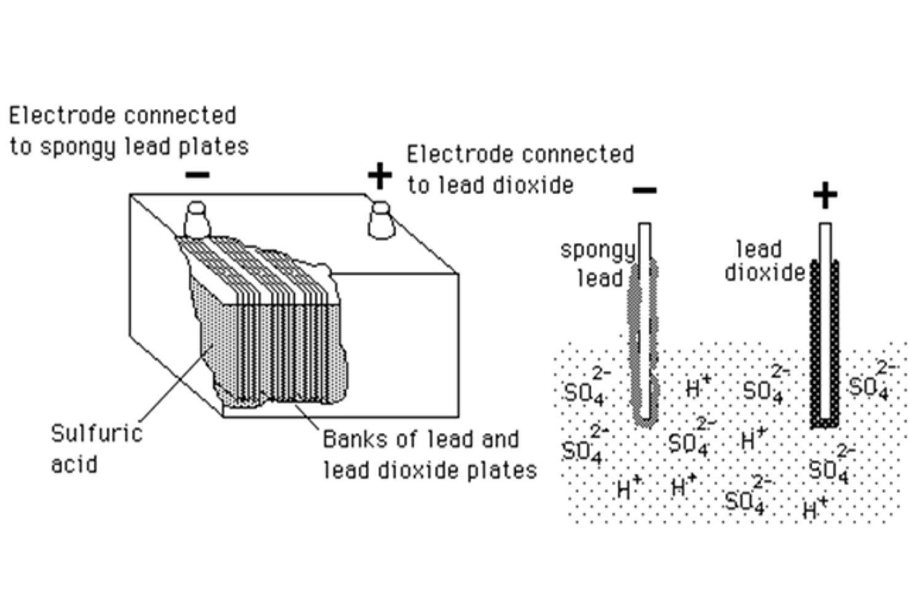

Alkaline fuel cell:



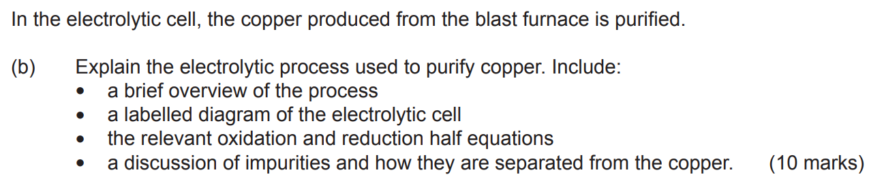

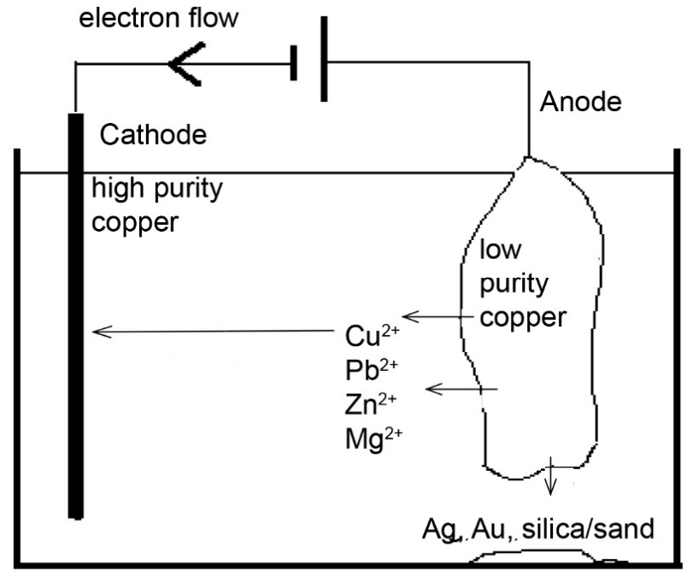

The electrolytic refining of coper involves the dissolution of an impure blister copper sample (anode) in a CuSO4 solution, and the subsequent deposition of Cu2+ ions as solid on the pure copper electrode (cathode).

A voltage is applied across the electrodes, giving a positive charge to the anode and a negative charge to the cathode.

This induces an otherwise non-spontaneous redox reaction in which copper is oxidised and reduced.

Oxidation reaction: Cu (s) → Cu2+(aq) + 2e–

Reduction equation: Cu2+(aq) + 2e– → Cu (s)

The electrons flow from the blister copper (anode) to the pure copper (cathode).

The dissolved Cu2+ ions then flow towards the cathode due to electrostatic attraction where they’re deposited as metallic solid.

Impurities in the original bliste copper sample are either dissolved in solution or drop down and form a mud as copper is preferentially oxidised and they don’t react.

The voltage is chosen so not to oxidise gold or reduce zinc, etc.

Similarities between galvanic and electrolytic cells:

* Both have an external wire for electron flow.
* Both have a cathode and an anode.
* Positive ions flow towards the cathode.
* Electrons flow through an external circuit from the anode to the cathode.
* An electrolyte/liquid/solution is needed.
* One substance is oxidised and the other is reduced.
* Oxidation occurs at the anode and reduction occurs at the cathode.

Differences between galvanic and electrolytic cells:

* A galvanic cell is linked to a load while an electrolytic cell is linked to a power supply.
* Galvanic cells are spontaneous while electrolytic cells aren’t.
* There’s only one cell in an electrolytic cell and 2 half-cells in a galvanic cell.
* A galvanic cell have a salt bridge while an electorlytic cell doesn’t.
* The galvanic cell has a spontaneous reaction while an electrolytic cell requires an emf to be supplied to force a reaction (non-spontaneous).
* The electrolytic cell has an external emf (battery/power source) while the galvanic cell produces the emf.
* Galvanic cell has a positive E0 while electorlytic cell has a negative E0.
* In a galvanic cell, chemical energy is converted to electrical energy while in an electrolytic cell electrical energy is converted to chemical energy.

Oxidation – Loss of electrons.

Reduction – Gain of electrons.

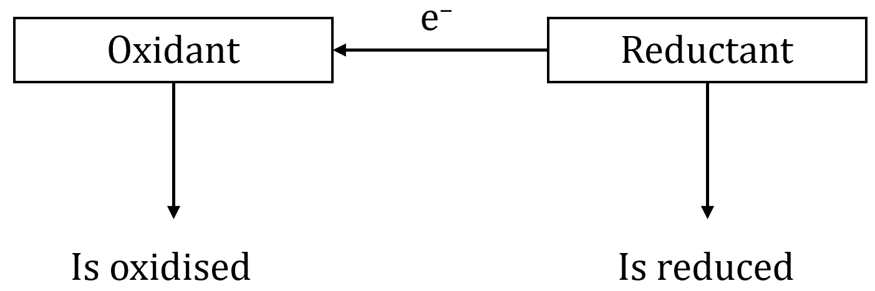

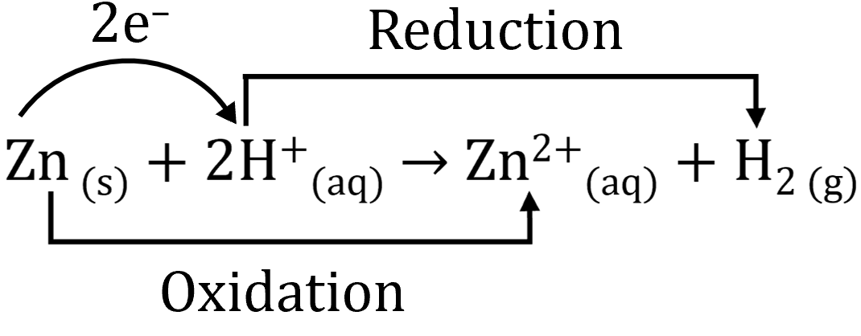

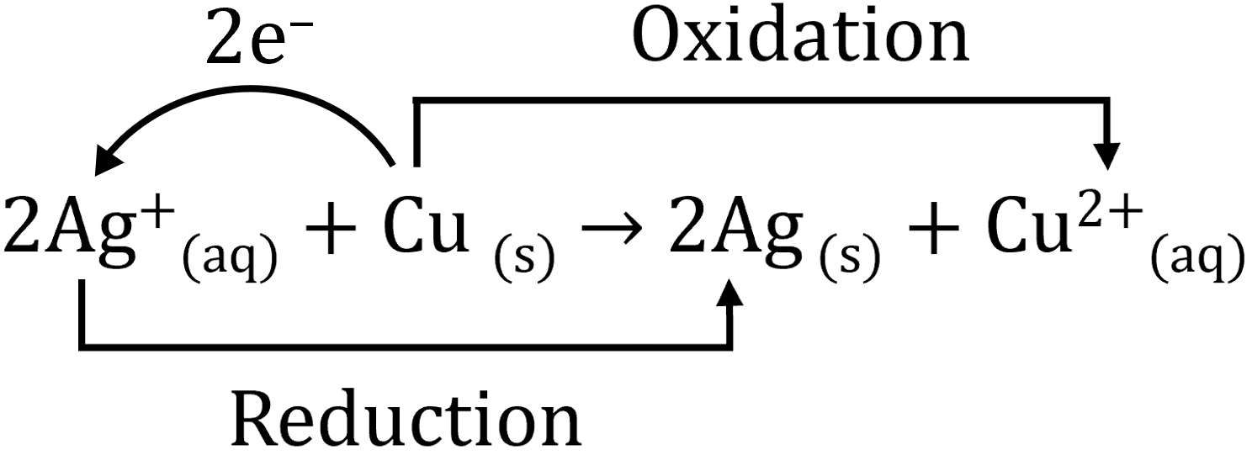

**OIL** Oxidation Is Loss of electrons.

**RIG** Reduction Is Gain of electrons.

Oxidising reagents/oxidants cause a substance to be oxidised. They have a tendency to accept electrons and are themselves reduced e.g., O2, Cl2, MnO4–, Cr2O72–, ClO–, H+ cone, HNO3.

Reducing reagents/reductants cause a substance to be reduced. They have a tendency to donate electrons and are themselves oxidised e.g., Zn, C, H2, Fe2+, C2O42–.

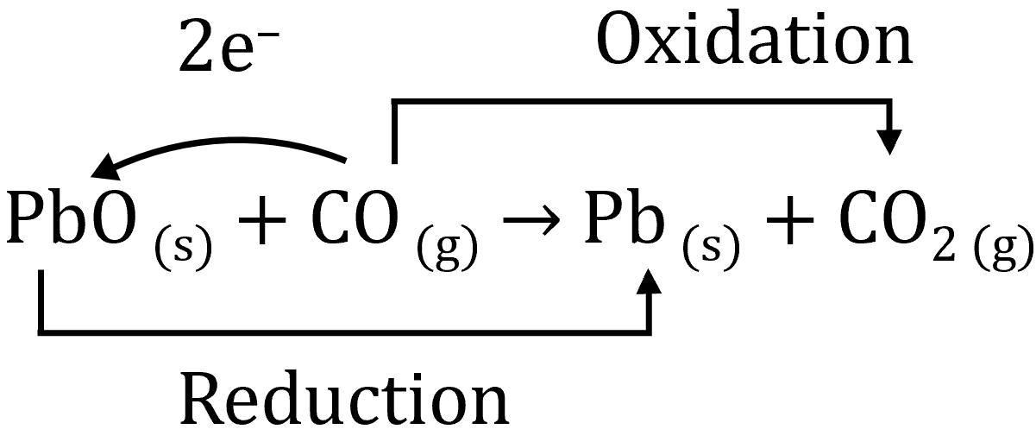

PbO accepts electrons and is reduced to Pb. Hence PbO is the oxidant.

CO donates electrons is oxidised to CO2. Hence CO is the reductant.

Oxidisation Numbers

Oxidisation numbers are arbitrarily assigned to atoms and are equal to the charge the atom would have if its bonds were purely ionic.

|  |  |
| --- | --- |
| Rules for assigning oxidisation numbers | |
| Species: | Oxidisation number: |
| 1. Atoms in the elemental state | 0 |
| 1. Monatomic ions   (Group I metals in combined states)  (Group II metals in combined state) | Charge on the ion  +1  +2 |
| 1. Oxygen in combined state   Exception 1: Peroxides e.g., H2O2, Na2O2  Exception 2: F2O | –2  –1  +2 |
| 1. Hydrogen in combined state   Exception: Metal hydrides e.g., NaH | +1  –1 |
| 1. For polyatomic species the sum of the oxidation numbers | Charge on the ion |

Oxidation → increase in oxidation number.

Reduction → decrease in oxidation number

.

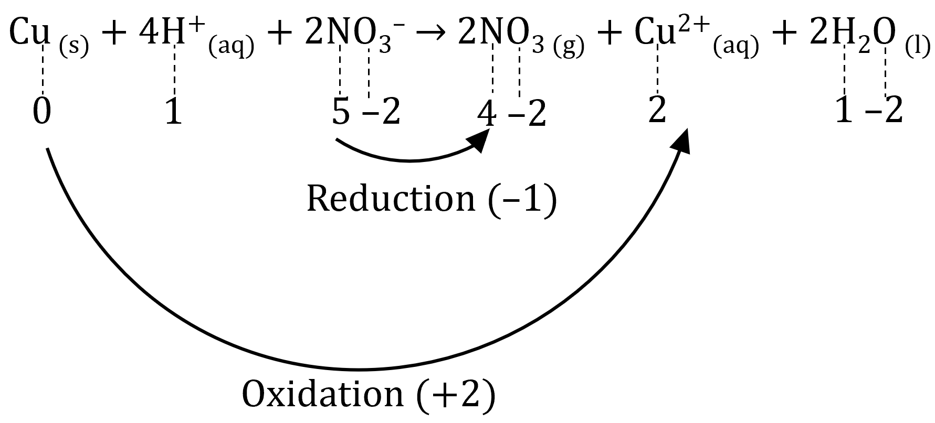

* Cu has been oxidised (0.N. 0→2).
* N has been reduced (O.N. 5→4).
* All other species have retained the same oxidation umber and hence have neither been reduced nor oxidised.
* This reaction is a redox reaction (both oxidation and reduction have occurred).

Half Equations

* Oxidation half equation: Zn (s) → Zn2+(aq) + 2e–
* Reduction half equation: Cu2+(aq) + 2e– → Cu (s)
* Redox equation: Zn (s) + Cu2+(aq) → Zn2+(aq) + Cu (s)

Balancing half-equations:

1. Use oxidation numbers to identify the element being oxidised or reduced.
2. Write a skeleton equation (reactant → product).
3. Balance the number of atoms of the element being oxidised or reduced.
4. Balance oxygen atoms by adding H2O.
5. Balance hydrogen atoms by adding H+.
6. Balance charge by adding electrons to the side that’s most positive.

Q: Write a half equation for the oxidation of:

[a] NO3–(aq) to NO (g) in acidic solution.

NO3–(aq) → NO (g)

NO3–(aq) → NO (g) + 2H2O (l)

NO3–(aq) + 4H+(aq) → NO (g) + 2H2O (l)

NO3–(aq) + 4H+(aq) + 3e– → NO (g) + 2H2O (l)

[b] PbO2 (s) to Pb2+(aq) in acidic conditions.

PbO2 (s) → Pb2+(aq)

PbO2 (s) → Pb2+(aq) + 2H2O (l)

PbO2 (s) + 4H+(aq) → Pb2+(aq) + 2H2O (l)

PbO2 (s) + 4H+(aq) +2e– → Pb2+(aq) + 2H2O (l)

Q: Balance the following redox reaction.

Reduction: NO3–(aq) + 2H+(aq) + e– → NO2 (g) + H2O (l)

Oxidation: Cu (s) → Cu2+(aq) + 2e–

(NO3–(aq) + 2H+(aq) + e– → NO2 (g) + H2O (l))2

Cu (s) → Cu2+(aq) + 2e–

Cu (s) + 2NO3–(aq) + 4H+(aq) → Cu2+(aq) + 2NO2 (g) + 2H2O (l)

Disproportionation Reactions

Disproportionation reactions occur when a substance undergoes self-oxidation and self-reduction. 2 important examples:

1. The decomposition of hydrogen peroxide.

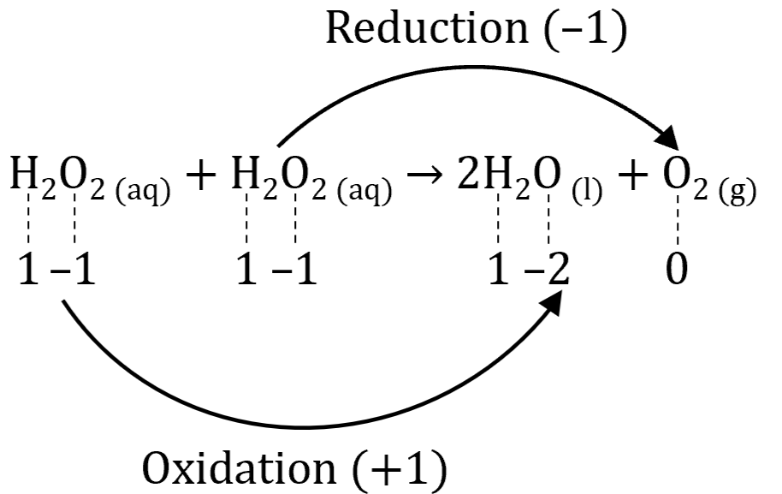

Note: The reactants can be grouped together to become 2H2O2 (aq).

1. The disproportionation of copper (I) ions in aqueous solution.

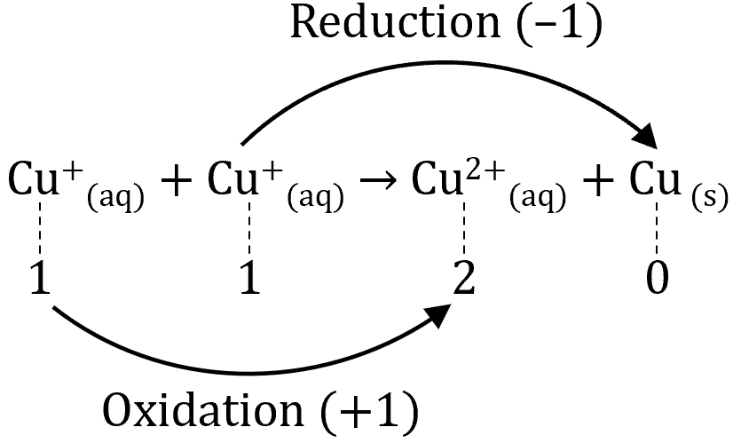

Note: The reactants can be grouped together to become 2Cu+(aq).

Competition for Electrons

The species being reduced has a greater ability or potential to gain electrons than the substance being oxidised.

Experiment 19

**Question 1**:

Zn + 2HCl → ZnCl2 + H2

Zn + 2H+ → Zn2+ + H2

|  |  |
| --- | --- |
| Oxidation | Zn ⇌ Zn2+ + 2e– |
| Reduction | 2H+ + 2e– ⇌ H2 |
| Overall | Zn (s) + 2H+(aq) → Zn2+(aq) + H2 (g) |

Mg + 2HCl → MgCl2 + H2

Mg + 2H+ → Mg2+ + H2

|  |  |
| --- | --- |
| Oxidation | Mg ⇌ Mg2+ + 2e– |
| Reduction | 2H+ + 2e– ⇌ H2 |
| Overall | Mg (s) + 2H+(aq) → Mg2+(aq) + H2 (g) |

Pb + 2HCl → PbCl2 + H2

Pb + 2H+ → Pb2+ + H2

|  |  |
| --- | --- |
| Oxidation | Pb ⇌ Pb2+ + 2e– |
| Reduction | 2H+ + 2e– ⇌ H2 |
| Overall | Pb (s) + 2H+(aq) → Pb2+(aq) + H2 (g) |

Cu + 2HCl → CuCl2 + H2

Cu + 2H+ → Cu2+ + H2

|  |  |
| --- | --- |
| Oxidation | Cu ⇌ Cu2+ + 2e– |
| Reduction | 2H+ + 2e– ⇌ H2 |
| Overall | Cu (s) + 2H+(aq) → Cu2+(aq) + H2 (g) |

Zn + Mg(NO3)2 → Zn(NO3)2 + Mg

Zn + Mg2+ → Zn2+ + Mg

|  |  |
| --- | --- |
| Oxidation | Zn ⇌ Zn2+ + 2e– |
| Reduction | Mg2+ + 2e– ⇌ Mg |
| Overall | Zn (s) + Mg2+(aq) → Zn2+(aq) + Mg (s) |

Zn + Pb(NO­3)2 → Zn(NO3)2 + Pb

Zn + Pb2+ → Zn2+ + Pb

|  |  |
| --- | --- |
| Oxidation | Zn ⇌ Zn2+ + 2e– |
| Reduction | Pb2+ + 2e– ⇌ Pb |
| Overall | Zn (s) + Pb2+(aq) ⇌ Zn2+(aq) + Pb (s) |

Zn + Cu(NO­3)2 → Zn(NO3)2 + Cu

Zn + Cu2+ → Zn2+ + Cu

|  |  |
| --- | --- |
| Oxidation | Zn ⇌ Zn2+ + 2e– |
| Reduction | Cu2+ + 2e– ⇌ Cu |
| Overall | Zn (s) + Cu2+(aq) ⇌ Zn2+(aq) + Cu (s) |

Mg + Zn(NO3)2 → Mg(NO3)2 + Zn

Mg + Zn2+ → Mg2+ + Zn

|  |  |
| --- | --- |
| Oxidation | Mg ⇌ Mg2+ + 2e– |
| Reduction | Zn2+ + 2e– ⇌ Zn |
| Overall | Mg (s) + Zn2+(aq) → Mg2+(aq) + Zn (s) |

Mg + Pb(NO3)2 → Mg(NO3)2 + Pb

Mg + Pb2+ → Mg2+ + Pb

|  |  |
| --- | --- |
| Oxidation | Mg ⇌ Mg2+ + 2e– |
| Reduction | Pb2+ + 2e– ⇌ Pb |
| Overall | Mg (s) + Pb2+(aq) → Mg2+(aq) + Pb (s) |

Mg + Cu(NO3)2 → Mg(NO3)2 + Cu

Mg + Cu2+ → Mg2+ + Cu

|  |  |
| --- | --- |
| Oxidation | Mg ⇌ Mg2+ + 2e– |
| Reduction | Cu2+ + 2e– ⇌ Cu |
| Overall | Mg (s) + Cu2+(aq) → Mg2+(aq) + Cu (s) |

Pb + Mg(NO3)2 → Pb(NO3)2 + Mg

Pb + Mg2+ → Pb2+ + Mg

|  |  |
| --- | --- |
| Oxidation | Pb ⇌ Pb2+ + 2e– |
| Reduction | Mg2+ + 2e– ⇌ Mg |
| Overall | Pb (s) + Mg2+(aq) → Pb2+(aq) + Mg (s) |

Pb + Zn(NO3)2 → Pb(NO3)2 + Zn

Pb + Zn2+ → Pb2+ + Zn

|  |  |
| --- | --- |
| Oxidation | Pb ⇌ Pb2+ + 2e– |
| Reduction | Zn2+ + 2e– ⇌ Zn |
| Overall | Pb (s) + Zn2+(aq) → Pb2+(aq) + Zn (s) |

Pb + Cu(NO3)2 → Pb(NO3)2 + Cu

Pb + Cu2+ → Pb2+ + Cu

|  |  |
| --- | --- |
| Oxidation | Pb ⇌ Pb2+ + 2e– |
| Reduction | Cu2+ + 2e– ⇌ Cu |
| Overall | Pb (s) + Cu2+(aq) → Pb2+(aq) + Cu (s) |

Cu + Mg(NO3)2 → Cu(NO3)2 + Mg

Cu + Mg2+ → Cu2+ + Mg

|  |  |
| --- | --- |
| Oxidation | Cu ⇌ Cu2+ + 2e– |
| Reduction | Mg2+ + 2e– ⇌ Mg |
| Overall | Cu (s) + Mg2+(aq) → Cu2+(aq) + Mg (s) |

Cu + Zn(NO3)2 → Cu(NO3)2 + Zn

Cu + Zn2+ → Cu2+ + Zn

|  |  |
| --- | --- |
| Oxidation | Cu ⇌ Cu2+ + 2e– |
| Reduction | Zn2+ + 2e– ⇌ Zn |
| Overall | Cu (s) + Zn2+(aq) → Cu2+(aq) + Zn (s) |

Cu + Pb(NO3)2 → Cu(NO3)2 + Pb

Cu + Pb2+ → Cu2+ + Pb

|  |  |
| --- | --- |
| Oxidation | Cu ⇌ Cu2+ + 2e– |
| Reduction | Pb2+ + 2e– ⇌ Pb |
| Overall | Cu (s) + Pb2+(aq) → Cu2+(aq) + Pb (s) |

**Question 2**:

The reactant in the oxidation row is the reducing agent.

The reactant in the reduction row is the oxidising agent.

**Question 3**: Listed from strongest to weakest: Mg, Zn, Pb, Cu

Experiment 20

**Question 1**:

Cl2 + 2Br –(aq) → 2Cl– + Br2

|  |  |
| --- | --- |
| Oxidation | Cl2 + 2e– ⇌ 2Cl– |
| Reduction | 2Br – ⇌ Br2 + 2e– |
| Overall | Cl2 + 2Br –(aq) → 2Cl– + Br2 |

Cl2 + 2I– → 2Cl– + I2

|  |  |
| --- | --- |
| Oxidation | Cl2 + 2e– ⇌ 2Cl– |
| Reduction | 2I– ⇌ I2 + 2e– |
| Overall | Cl2 + 2I– → 2Cl– + I2 |

Br2 + 2Cl– → 2Br – + Cl2

|  |  |
| --- | --- |
| Oxidation | Br2 + 2e– ⇌ 2Br – |
| Reduction | 2Cl– ⇌ Cl2 + 2e– |
| Overall | Br2 + 2Cl– → 2Br – + Cl2 |

Br2 + 2I– → 2Br – + I2

|  |  |
| --- | --- |
| Oxidation | Br2 + 2e– ⇌ 2Br – |
| Reduction | 2I– ⇌ I2 + 2e– |
| Overall | Br2 + 2I– → 2Br – + I2 |

I2 + 2Cl– → 2I– + Cl2

|  |  |
| --- | --- |
| Oxidation | I2 + 2e– ⇌ 2I– |
| Reduction | 2Cl– ⇌ Cl2 + 2e– |
| Overall | I2 + 2Cl– → 2I– + Cl2 |

I2 + 2Br – → 2I– + Br2

|  |  |
| --- | --- |
| Oxidation | I2 + 2e– ⇌ 2I– |
| Reduction | 2Br – ⇌ Br2 + 2e– |
| Overall | I2 + 2Br – → 2I– + Br2 |

**Question [2]**:

Part [a]: Reactants in the reduction row.

Part [b]: Reactants in the oxidation row.

Part [c]: ?

**Question [3]**:

Listed from strongest to weakest: Cl2, Br2, I2